CE 319F Laboratory 5 - Flow Visualization

Handout

Objectives

The objectives of this lab are to understand some flow visualization techniques in physical experimentation and, in the process of learning about these techniques, to also learn about some specific types of flows and applications.

Background

Flow visualization incorporates many basic principles involved in fluid mechanics. Observation of fluid flow can give insight into concepts such as velocity, pressure, and force.

There are three basic patterns used to describe flows:

- Streamline: a line everywhere tangent to the velocity vector at a given instant in time
- Pathline: the actual path traversed by a given fluid particle
- Streakline: the locus of particles that have previously passed through a prescribed point

Pathlines and streaklines are easily created in the lab and using imaging techniques in field scenarios by various flow visualization techniques. Flow visualization can be accomplished by many different methods, some of which are listed below:

- dye, smoke, bubble discharges
- floating particles on water surfaces
- bioluminescence
- optical laboratory techniques – particle image velocimetry (PIV), laser induced fluorescence (LIF), infrared imaging

Optical Laboratory Techniques – PIV & LIF

Particle Image Velocimetry (PIV)

Particle Image Velocimetry is a non-intrusive technique that is used to measure the instantaneous velocity field. The velocity measurements are made by seeding the fluid of interest with neutrally-buoyant (neither sinking or floating) seeding particles that travel passively with the fluid over a known interval of time. The fluid and seeding particles are illuminated with a pulsing laser light sheet and the flow is recorded using a high speed camera. The pulsing laser and the camera are synchronized such that when the seeding particles are illuminated during the powerful light pulse, the camera can capture the image. The delay between the laser pulses allows two adjacent photos to track the displacement of the particles. By capturing images through time, the displacement of the particles can be tracked and can be used to calculate the velocity of the flow through the following relationship:

Speed = Distance / Time

In order to process the data, each image is divided into M*N pixels interrogation areas in order to track the displacement of the seeding particles. The interrogation areas are correlated to then produce particle displacement vectors. Through the use of a calibration tool (e.g. ruler), the size of a pixel can be scaled to the physical dimension (mm). By dividing the physical dimension by the time between two sets of images, the displacement vectors are converted into velocity vectors. The workflow for processing the data can be seen in Figure 1.

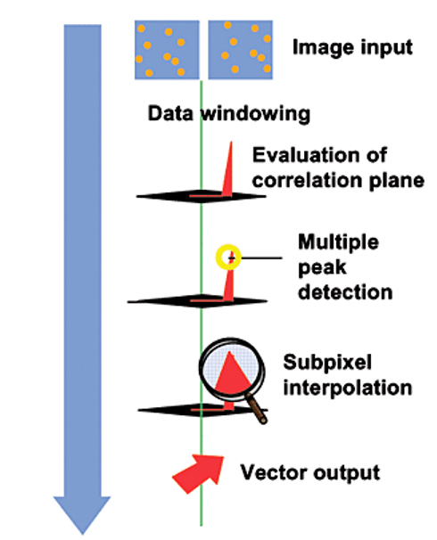

Figure 1. PIV Processing Workflow

Laser Induced Fluorescence (LIF)

Laser induced fluorescence (LIF) is another non-intrusive technique for measuring scalar concentrations (e.g. temperature, density contaminants, etc.) in fluid flows. Fluorescent dye is injected or mixed with the liquid as a scalar proxy. It is then excited by a thin planar laser sheet and fluoresces brightly. Depending on the user and experiment(s), a particular pair of fluorescent dye and laser is used to relate the fluoresced color ⇒ dye concentration ⇒ scalar evolution. Fluid flow is recorded via a high speed camera at a high resolution and bit-depth to accurately capture the wide ranging light intensities emitted from the excited dye as the scalar evolves in time and space. See Figure 2 as a reference.

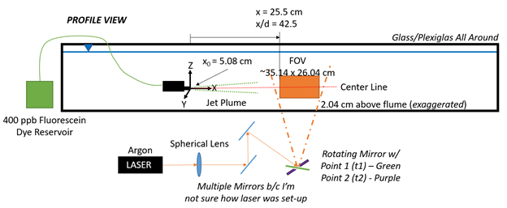

Figure 2. Example LIF turbulent jet experimental set-up schematic

In order to process the data, a calibration curve matrix is produced by taking various still images of sequential dye and scalar concentrations to relate these concentrations to the light intensities captured by the camera. Assuming a linear relationship between dye/scalar concentrations and light intensities, the user can convert light intensities to the scalar in question in the experiment to study its evolution in the flow. See Figure 3 as a reference.

Use of experimental procedures for some of the ongoing experiments taking place at the Johnson Environmental Turbulence (JET) Lab

Luisa’s Correlating Entrainment Mechanisms and Turbulence in a Buoyant Plume to Large-Scale Visual Structures Experiment:

PIV will be used to track the instantaneous velocity field of a buoyant plume that is rising through a standing tank of water. By seeding the plume with fluorescent dye, LIF will be used to measure entrainment (the process of one liquid engulfing another liquid due to shear) and to visually highlight mixing processes. By coupling LIF and PIV, the instantaneous velocity field from PIV measurements will be used to calculate statistics of the turbulent flow and correlate it with entrainment rates seen with LIF. Additional videos of the three-dimensional exterior of the plume will also be used to visually identify areas with large eddies with the aims of modeling field observations of buoyant plumes.

Junior’s Erosion of a Sharp Density interface by Homogeneous Isotropic Turbulence Experiment:

PIV will be used to track the instantaneous velocity field of the interaction between two fluids of distinct densities as turbulence generated above the stratified system forces the two layers to mix. Simultaneous LIF measurements be obtained to capture: erosion of the density interface; entrainment of the lighter fluid into the denser fluid; and mixing of the system as a whole. Statistical metrics of the turbulence by PIV will be coupled with the evolution of the concentration profiles by LIF to characterize under what turbulent and fluid conditions a two layer density system mixes or remains stratified.

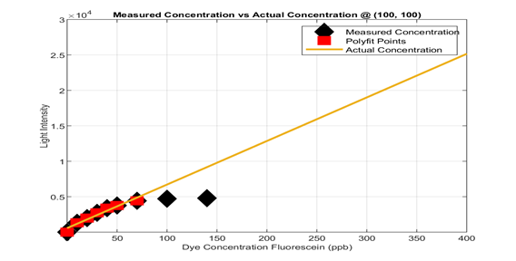
Figure 3. Example calibration curve at one pixel location

Laboratory Procedures

When water moves, it’s clear – it’s hard to see where it’s going or how fast. If there are bubbles, leaves, or other distinct features we can decipher flow characteristics to ultimately measure velocities, flow rates, and other metrics. In this lab, we will be using floating tracers (mini rubber ducks!) to visualize flow patterns in Waller Creek. We will run several experiments to give us enough information to draw streamlines, streaklines, and pathlines along Waller Creek in order to visualize how the flow changes as a function of bathymetry, width, obstructions, etc. along the span of creek behind ECJ.

- Streaklines and pathlines:

  - To generate streaklines, a student will continuously release ducks into Waller Creek at the same point, so that all ducks downstream will have, at some instant in time, have passed through the same location. The timing of the duck releases will depend on the speed of the creek, whether every 5 seconds, 20 seconds, or minute.

  - To trace out the pathlines, a few students will monitor the pink ducks that are also passing downstream. So perhaps every 4th duck released will be pink to have them easier to track. In particular, watch to see if all pathlines are identical, whether they cross, whether they seem parallel, etc.

  - If we know the regular time interval at which the student is releasing the ducks, we can calculate the velocity as distance traveled per unit time. So while the streaklines are being traced during this experiment, several students can also be using tape measures to determine the velocity at several stretches along the creek.

- Streamlines

  - To generate streamlines, we need to visualize a spatial array of ducks and the patterns they create. Ideally we would get to take many photos in rapid succession to trace out the velocity vectors tangent to the ducks’ motion. Instead, we will simply drop all (or a lot!) of the ducks into the creek at once and see how they travel as a group across a two-dimensional surface.

  - During this experiment, come up with answers to the following questions: How do the patterns evolve as the creek narrows and expands? Can you detect and recirculation cells? Is this actually a good way to generate streamlines?

- Throughout the experimental runs, be thinking about whether the flows appears to be steady, unsteady, uniform, non-uniform, etc. and potential reasons for each. Does the velocity field make sense? Did any ducks go backwards? Spin in circles? Why? Why not?

Keep in mind a few ground rules for this lab session:

- Stay together as a group and stay attentive to your TA. This is not an opportunity to wander over to Taco Joint!
- Be careful not to slip in the creek, trip over a tree branch, get poison ivy (leaves of three, let it be) or suffer any environmental hazard. If there is an incident, please notify your TA immediately for help.
- Cell phones are not to be used unless specifically directed by the TA. Phones might be used for timing duck releases and/or taking video recordings of the ducks, and please limit usage otherwise.
- No duck left behind – ensure that all ducks are collected back into the buckets at the end of the lab session!
- Waller Creek is a highly polluted creek. Please wash your hands when you return inside if you were handling ducks and/or had any contact with the water. Rubber gloves will be available as well.
- Use common sense! Be smart, be safe, and have fun.

